**Problem Statement & Requirements:**

Based on the teams formed, each team is supposed to create a web application of the proposed functionalities in the previous assignments. Each team can be divided into Group G1 and Group G2; G1 is supposed to work on the front-end and G2 on the back-end sections, respectively. You can use Flask + MySQL for developing your WebApp.

The web app should support the dynamic execution (The changes done by the user through the web app shall be reflected in the main database and web page also) of the following functions on your database:

* INSERT
* UPDATE
* DELETE
* RENAME
* WHERE clause

Push it to GitHub and share the link for submission.

Please note that all the constraints mentioned in Assignment 1 and 2 should be implemented and functioning in your application.

Login page with authentication of users and stakeholders.

**3.1 Responsibility of G1:**

G1 is supposed to design the front end and beautify accordingly using HTML/CSS/JS, you may use any other libraries for the front end, such as Bootstrap or jQuery. But flask is mandatory.

Screenshots:

* **Login**: Login intreface

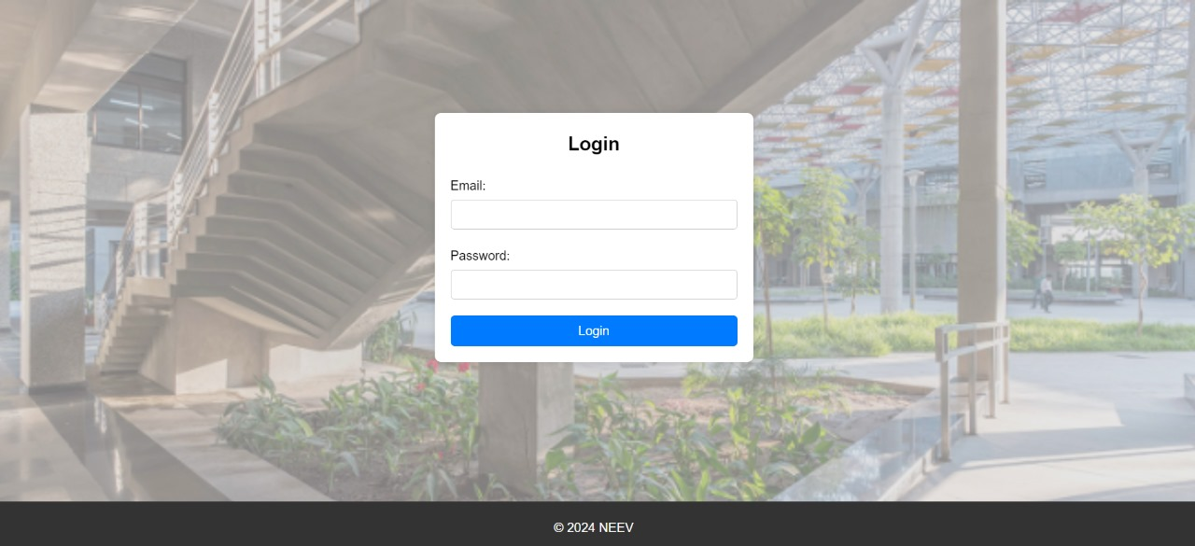

* **Admin Dashboard:** The front page for the Admin.

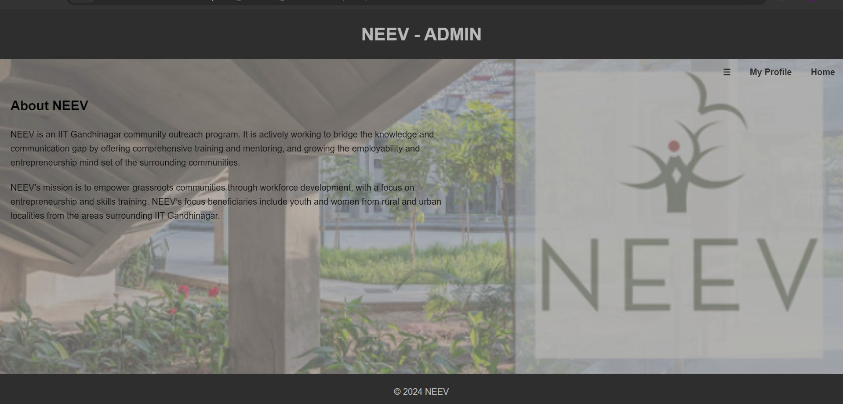

**Main Dashboard: The main page for NEEV members.**

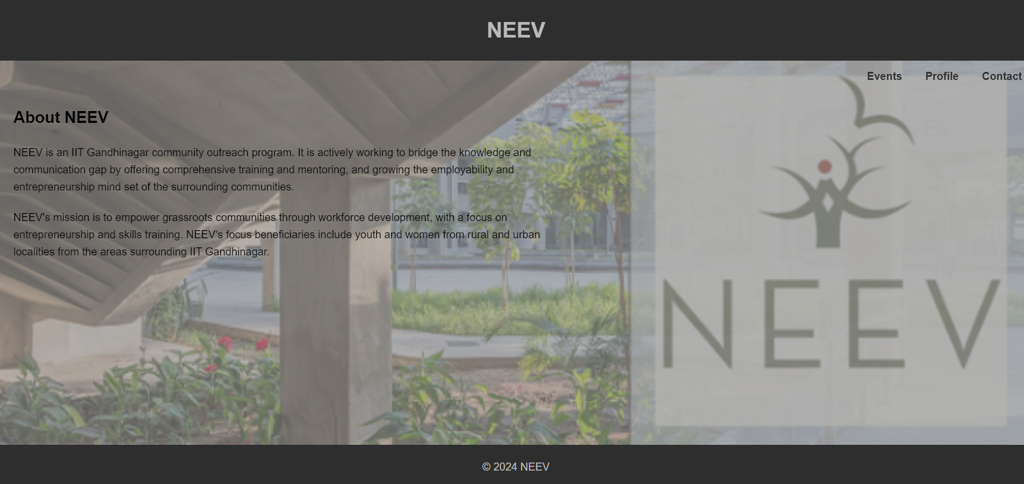

* **Neev_members Dashboard: This page is displayed for the neev members**

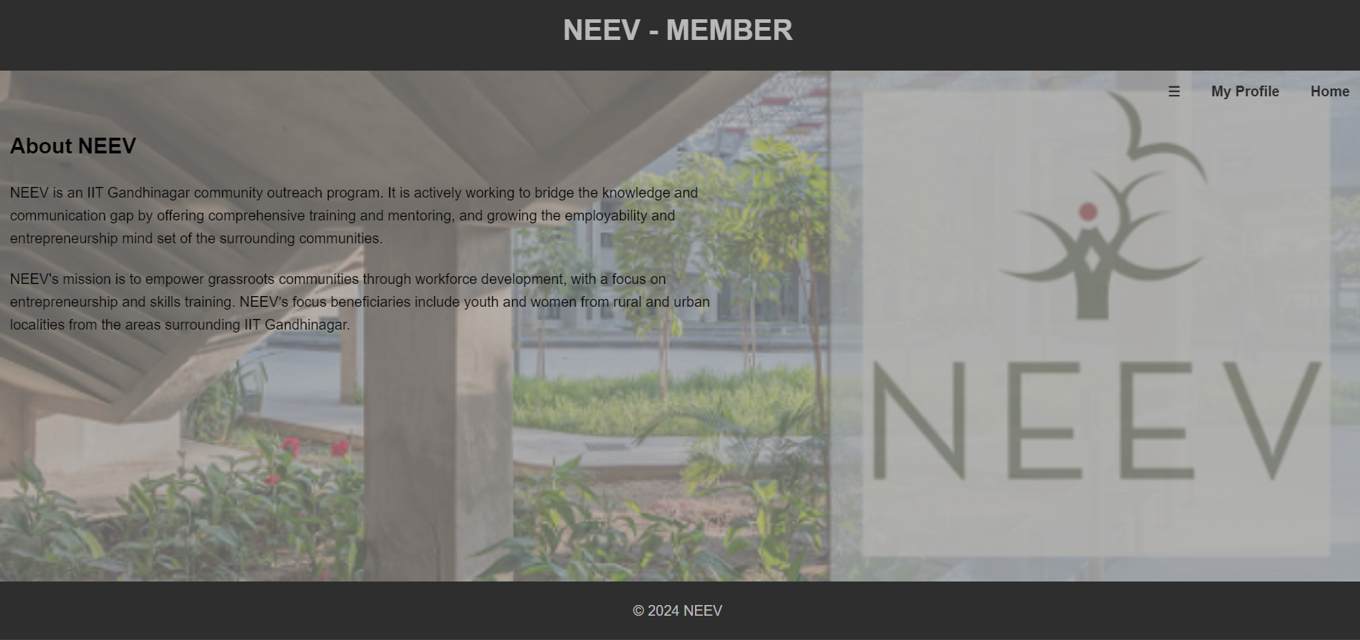

* **Add Instructor page**: Admin can add Instructor using the information below.

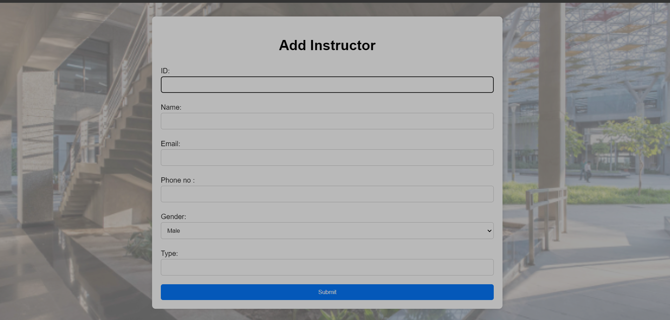

* **Add Course page**: Admin can add the course using following information below.

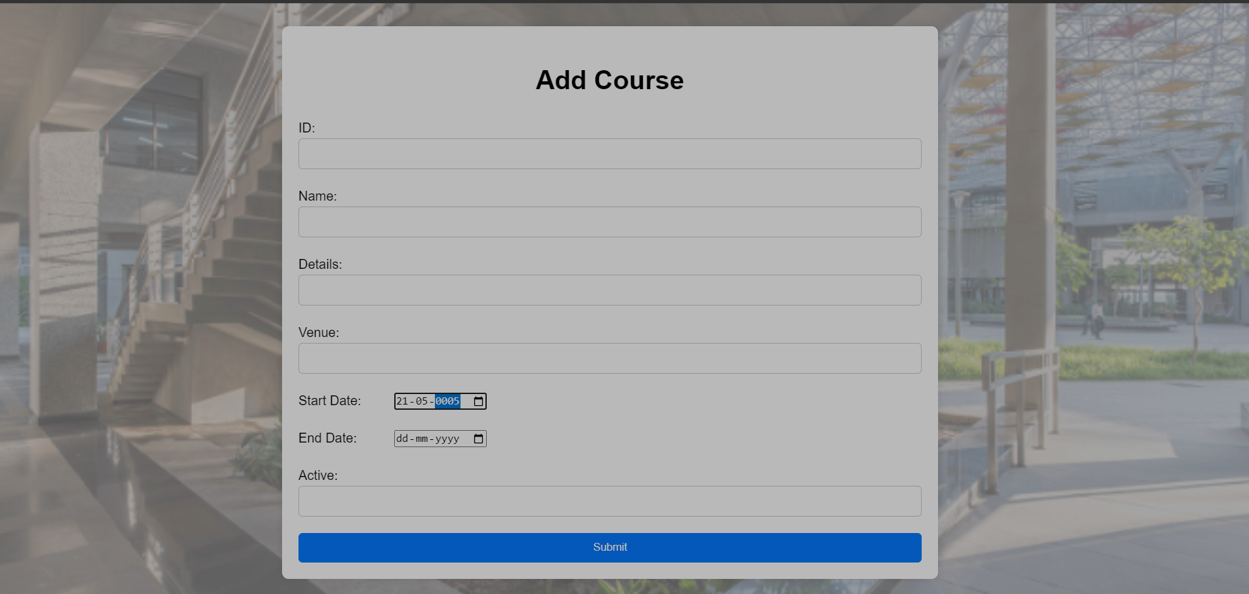

* **Add Voluntteer**: Admin can add volunteer using below information.

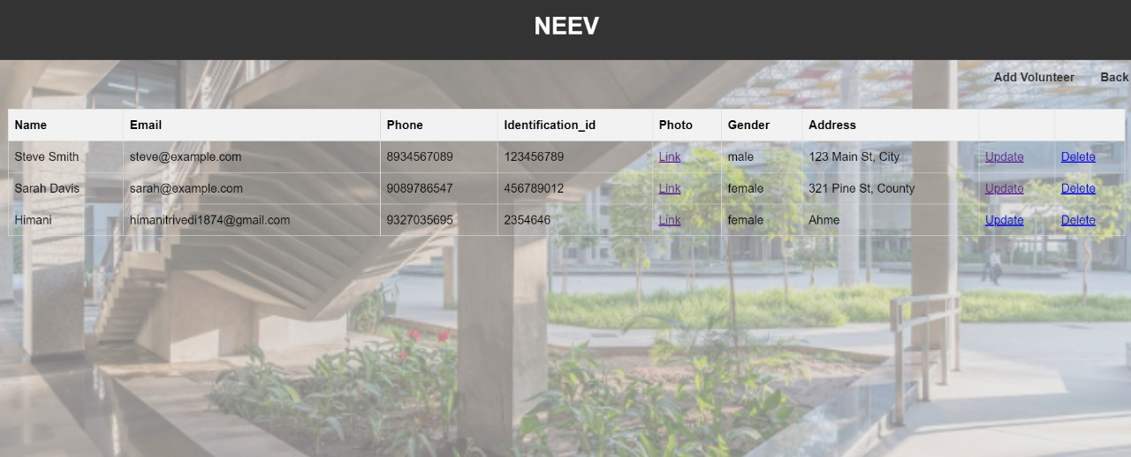

* **Add Voluntteer**: Admin can add donor using below information.

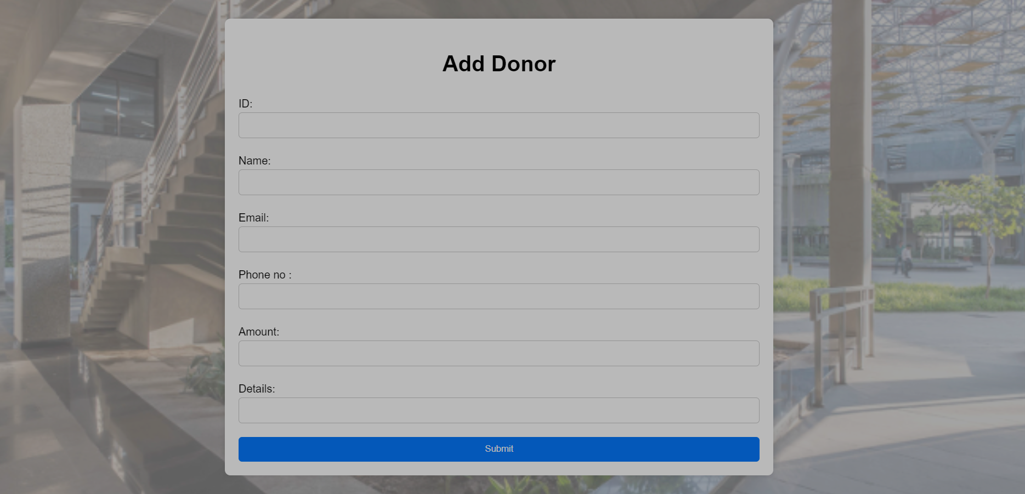

* **Add Neev member**: Admin can add the course using following information below.

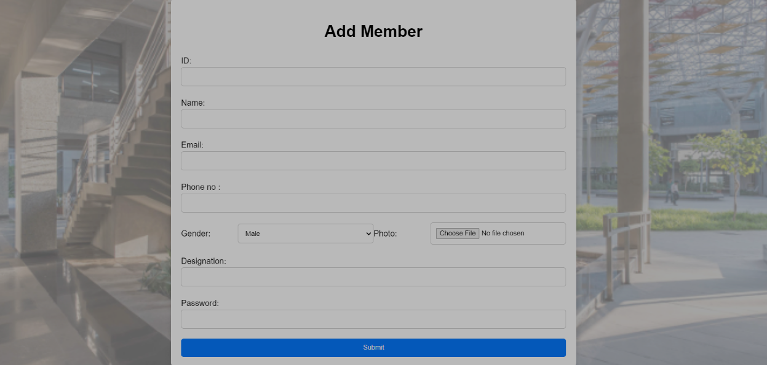

* **Add Student:**  members of Neev can add the student using following information below.

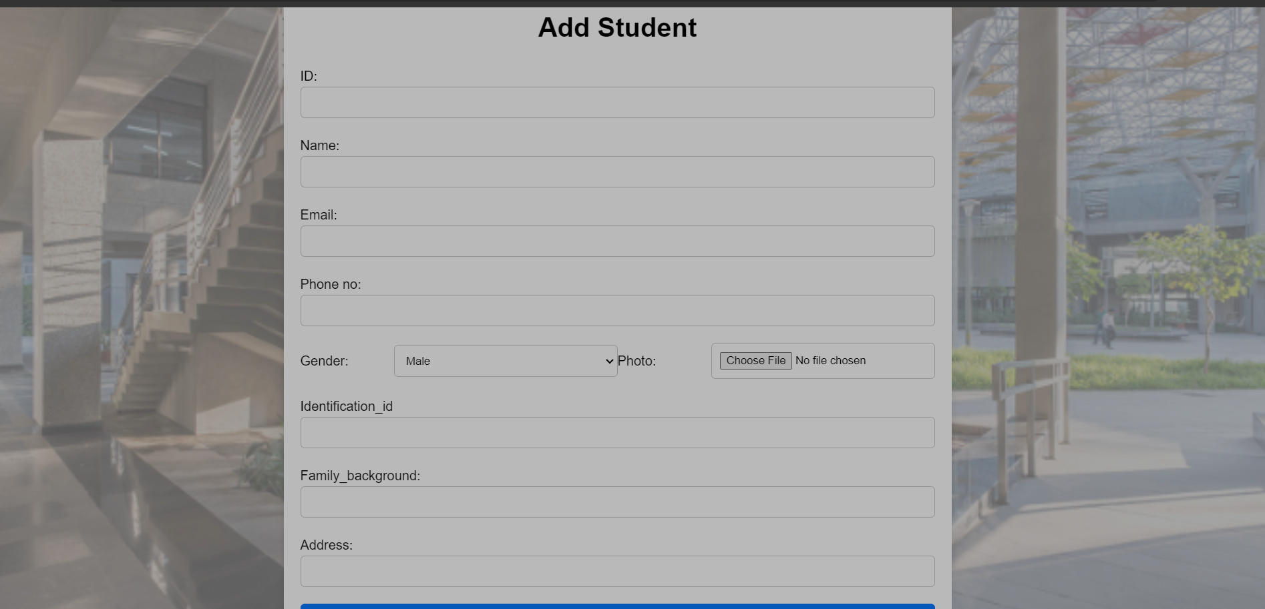

* Courses: Below interfaces shows the list of courses in NEEV. The Column ‘Active’ shows the active course is the course available in specific time period

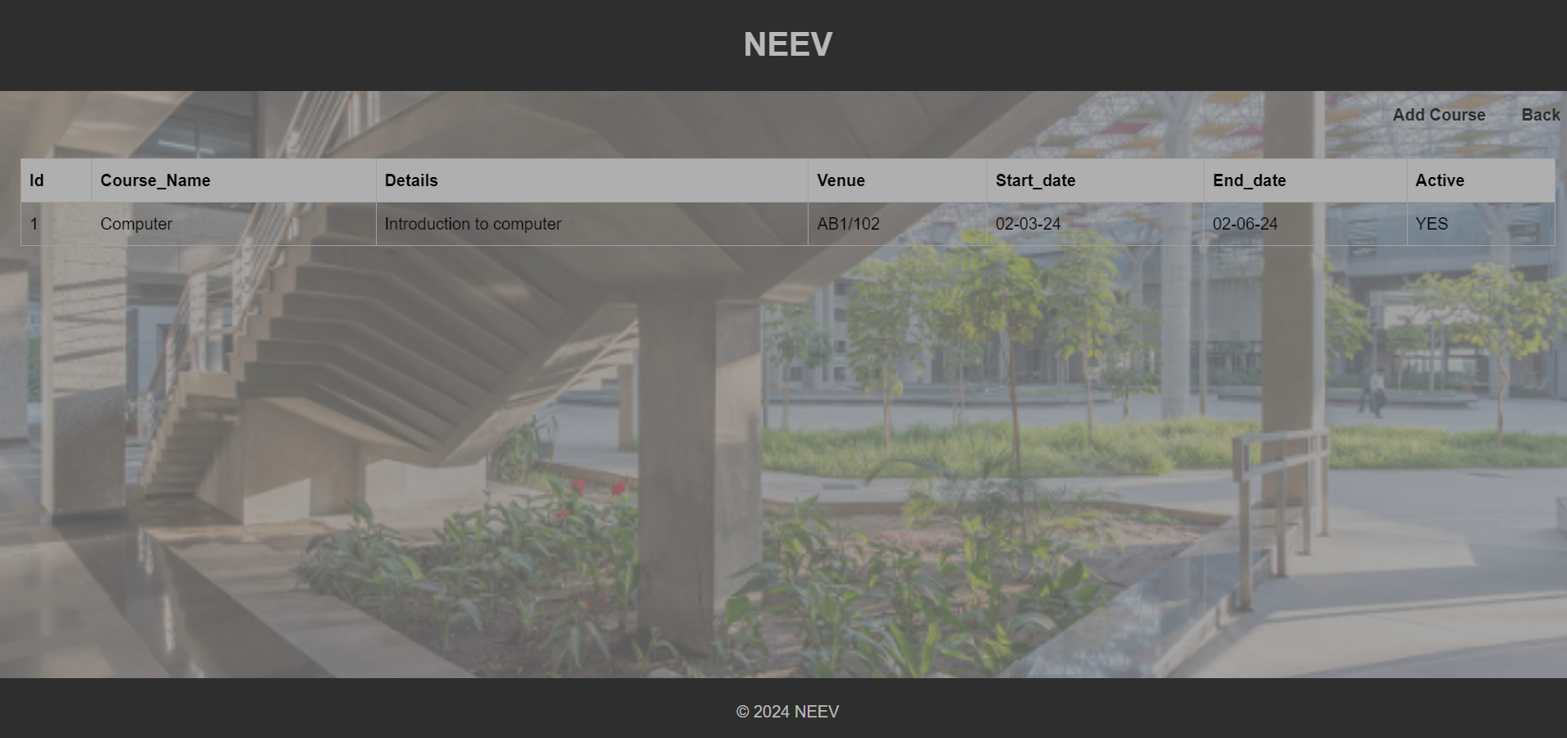

* The page too see the past events.

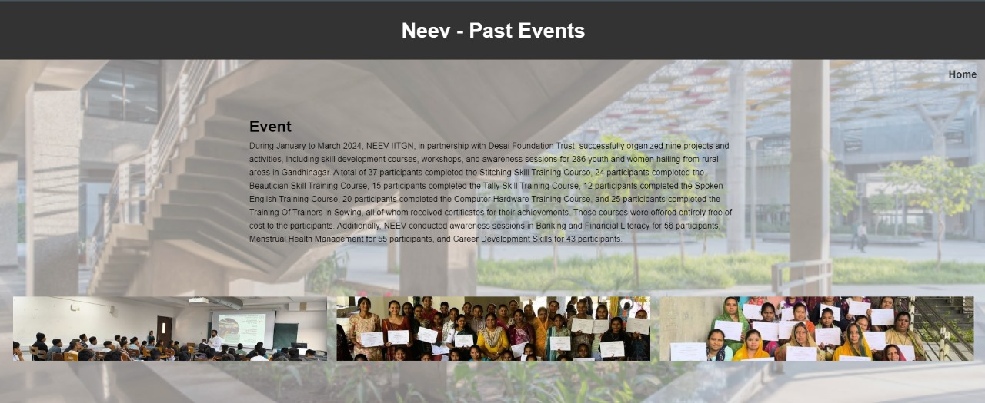

* To know the contact details

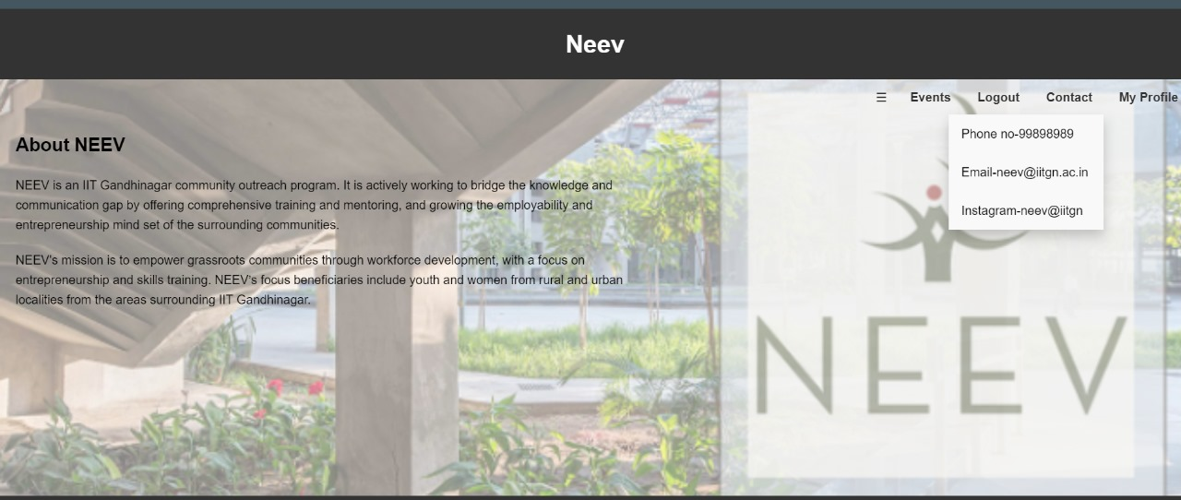

**Similarly, the page for Neev members is present. But the neev members can add Volunteer, Students, Courses, Instructor. Also, neev members cannot add Donor and Any other neev member.**

**Responsibility of G2:**

G2 has to work on integrating MySQL in WebApp. This group works on the proper working of the backend.

* 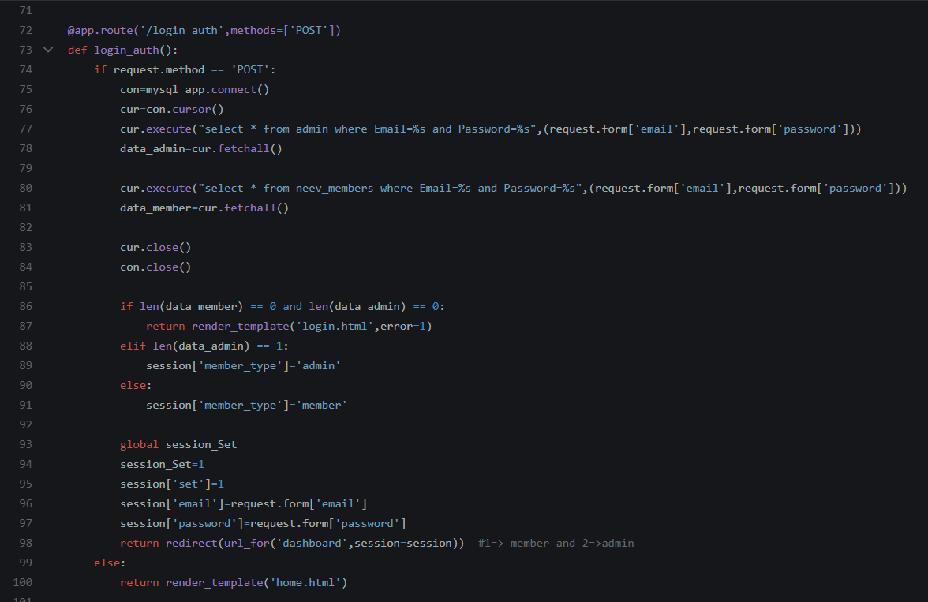**Query for Login Authentication, for both admin side and member side**.
* **Query to display profile**

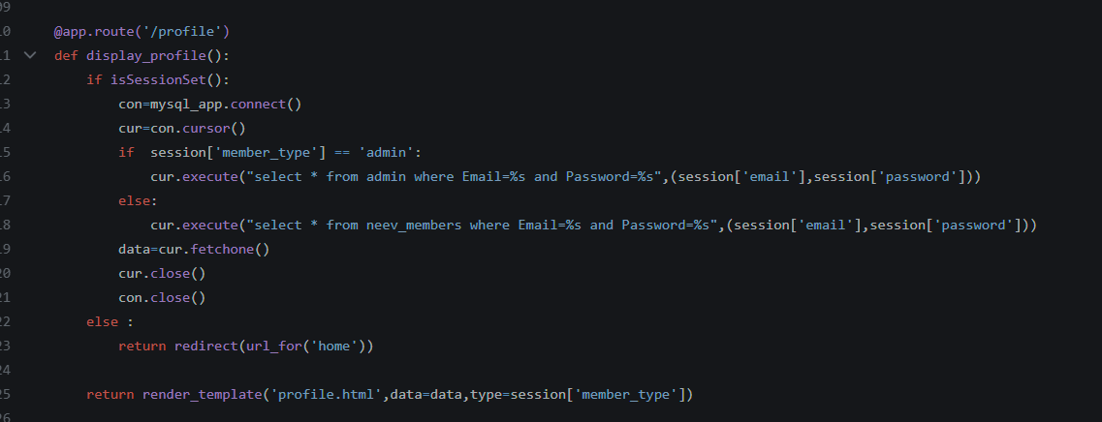

* **Query to activate course:**

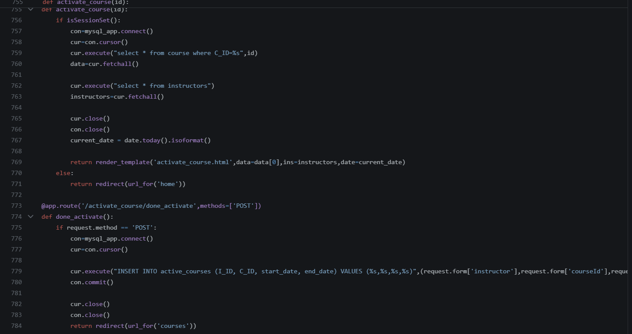

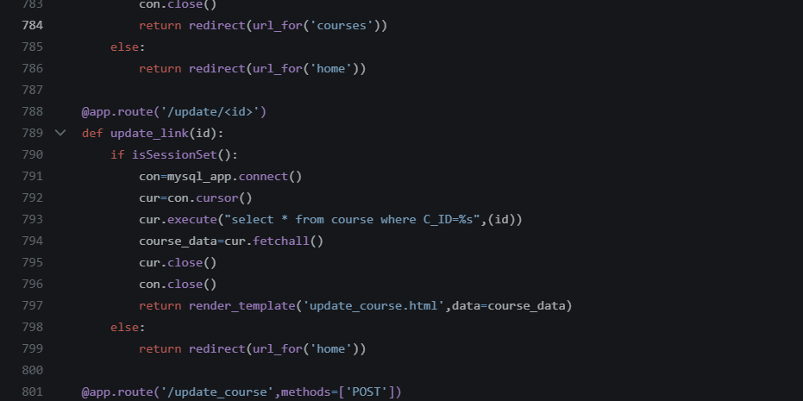

* **Query to update the link:**

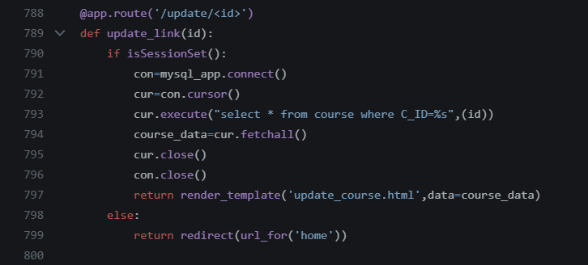

* **Query to add course details:**

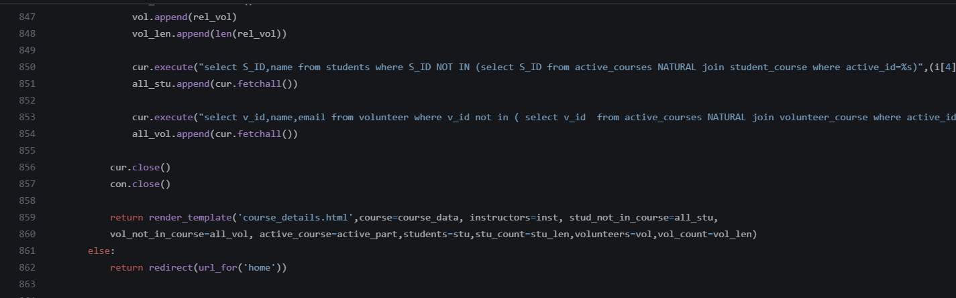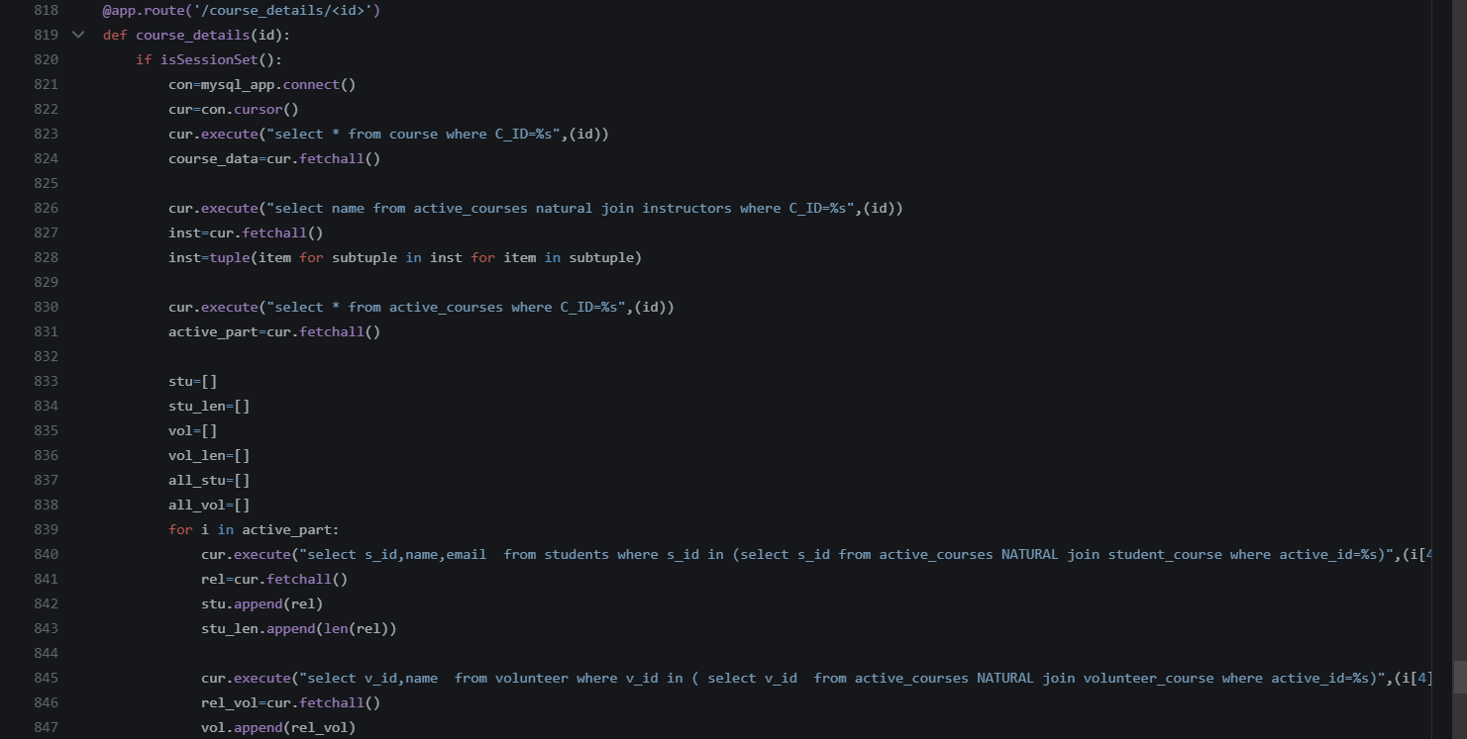

* **Query to add volunteer:**

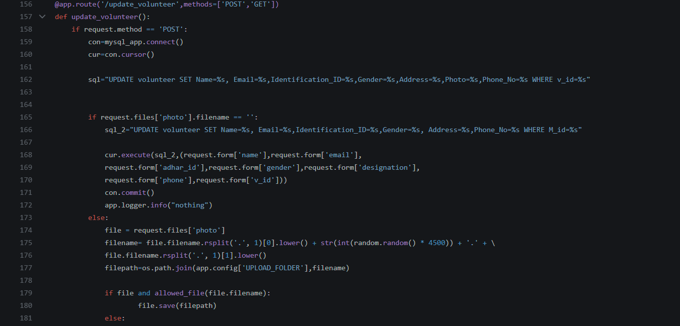

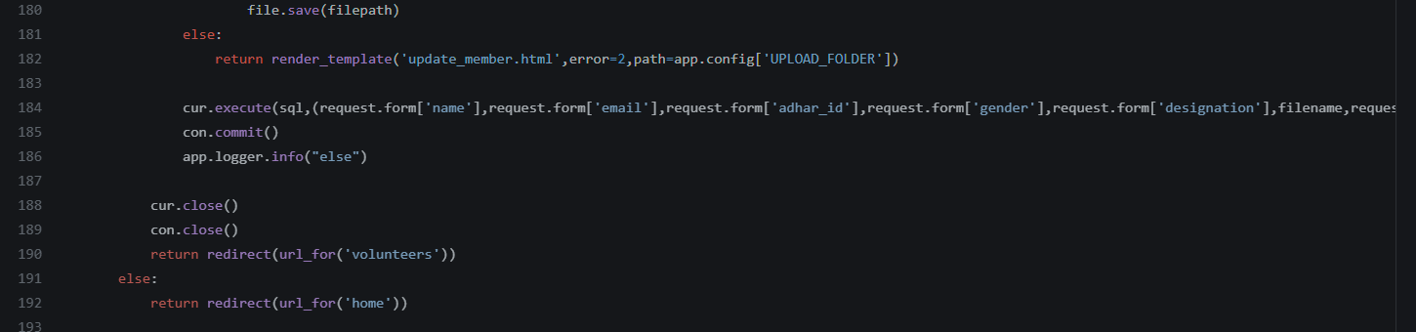

* **Query to remove volunteer Delete volunteer**

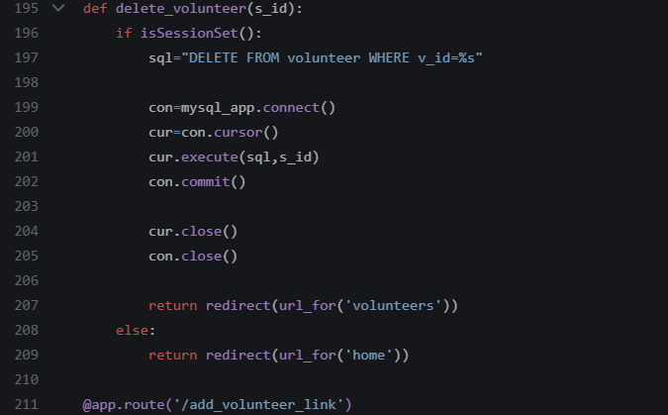

**For all students, members, volunteer, Instructor. All the queries and same to add and delete.**

**Responsibility of G1 & G2:**

1. Create the database of the designed logical schema in your previous assignment number 2, enter dummy/imaginary values into it, and show these dummy entries on the web page.

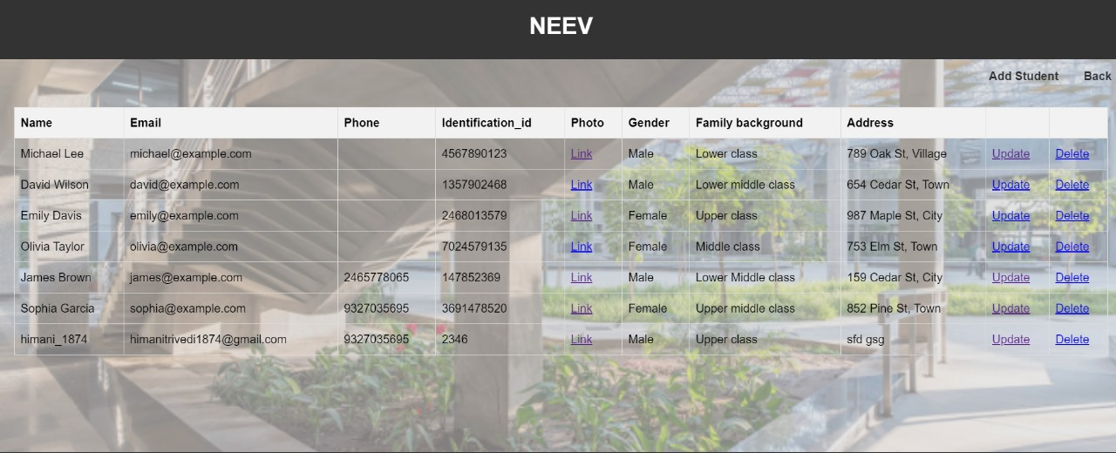

The web app should support the dynamic execution (The changes done by the user through the web app shall be reflected in the main database and web page also) of the following functions on your database:

1. **INSERT**

* **Before Adding:**

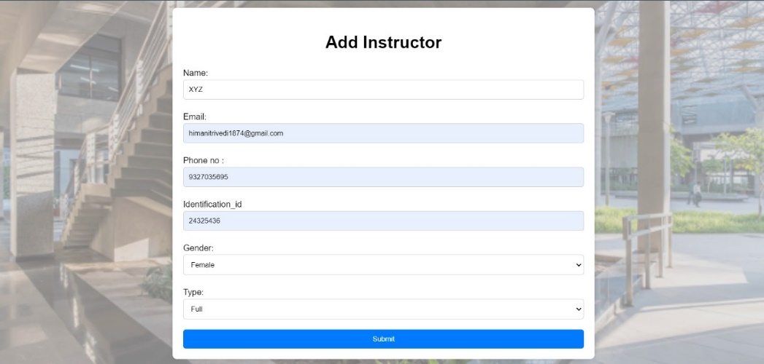

* **After Adding:**

We are adding the instructor:

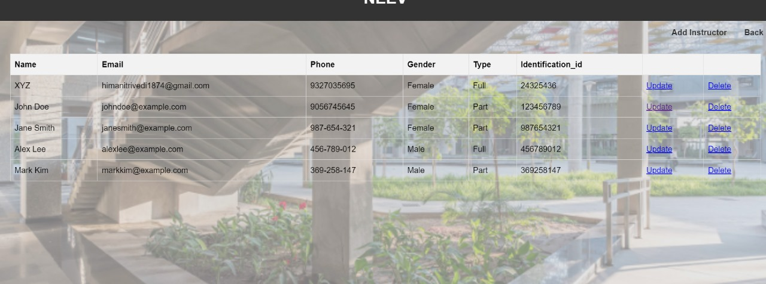

1. **Update:**

* **Before:**

Here the surname of Mark is Kim

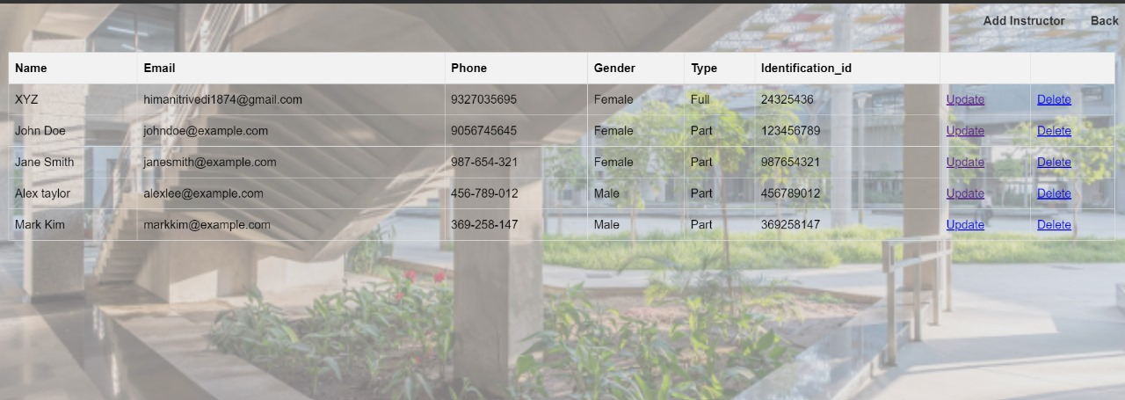

* **After:**

**Updated the surname and mobile.no. of the Mark joo**

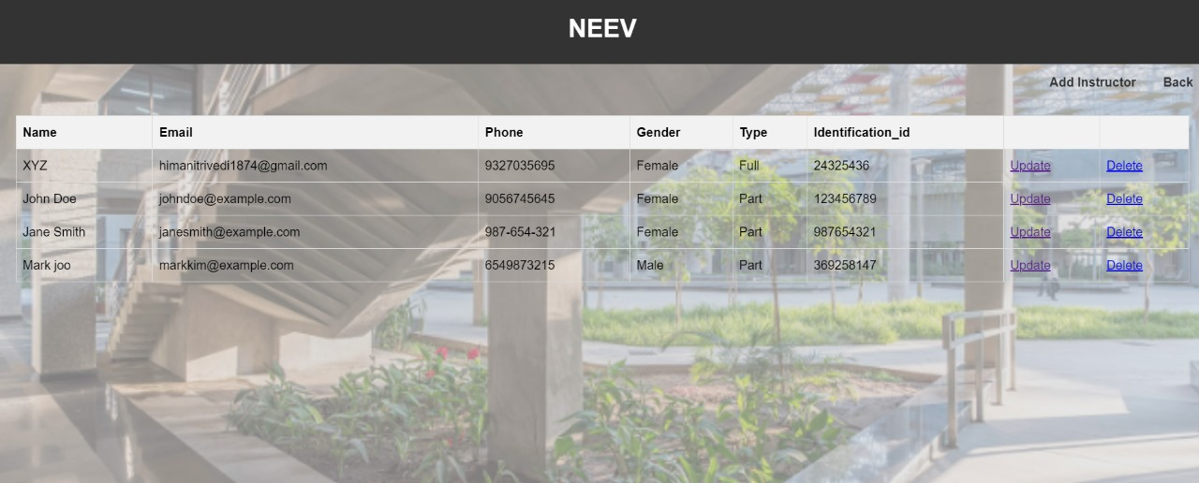

* **It also shows the image not available if the image is not uploaded**

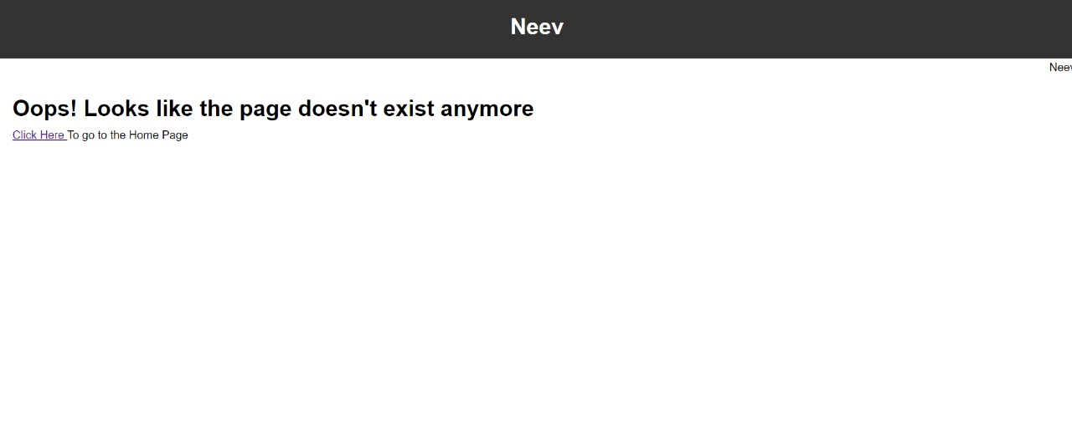

**3.Delete:**

* **Before**



* **After:**

Deleted the Instructor named Alex Taylor



**4. Rename:**

Our system doesn't require any rename operation to do so we haven't implemented/shown it and there is no point to rename table, database or column.

**5. WHERE clause:**

The Course list:



The Course Detail:

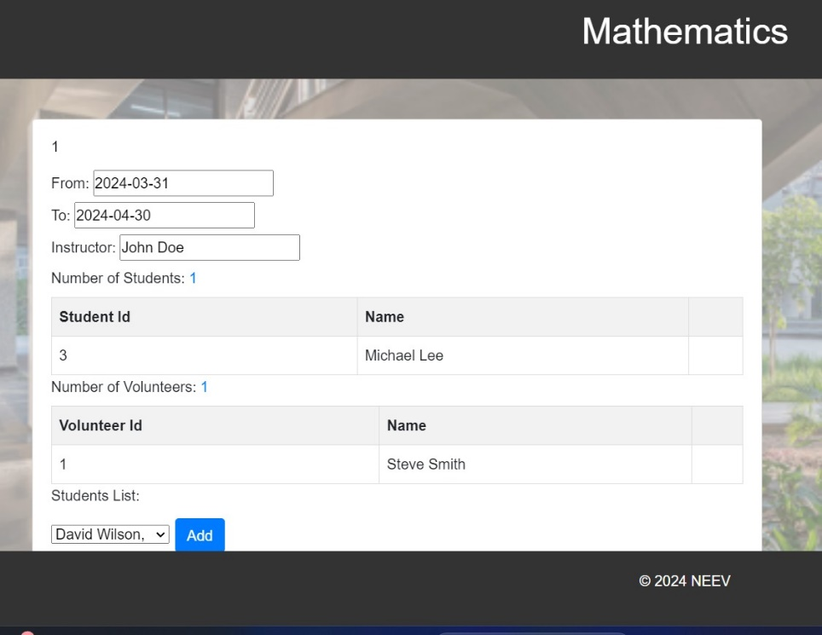

Contribution:

G1 Priya Darji, Om Ambekar, Diya Parashar

G2: Himani Trivedi, Dhru Jain

G1 & G2: Priya Darji, Om Ambekar, Diya Parashar Himani Trivedi, Dhru Jain

Documentation: Dhru Jain